**Process for Quality Testing.**

Misionero’s studios will use a cyclic process to test and control the quality of every feature and development of the game Mythologic Parade, this will consist of the following stages:

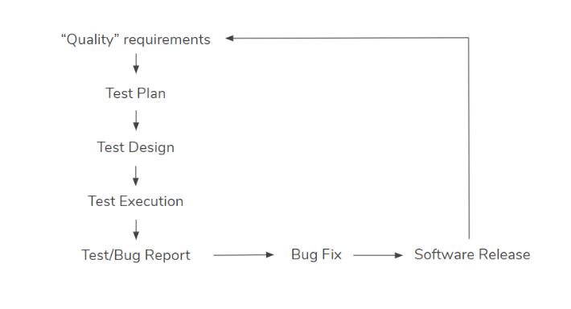

**“Quality” requirements:**

For every task done in our team we have our own system of delivery to ensure all tasks and new features do not break the game and that way avoid further problems.

The way to accomplish this is using the same protocol for every task or feature done before its uploaded to github an added definitively in the game, the member who did the task will have to tag it with a specific state to let know the rest of the team that this task is waiting for approval and it will be revised by specific members of the team to be accepted and finally added in game.

It could seem a slow process but it will speed up the process when working in small teams for every part of the game cause they will ensure their own task does not crush the game and the other teams will focus in their tasks only and at the same time we will save time by avoiding a lot of errors.

This quality requirements are explained in the following section: *Milestone Delivery Protocol.*

**Test Plan:**

The plan created to testing the game will try to give us the more time as possible to develop the game and at the same time correct the possibles errors and bugs. So this workflow plan is defined the same for all the team to all be conscious of the progress of the game and the others teams work.

This test plan is shown in the following images:

**May 2020**

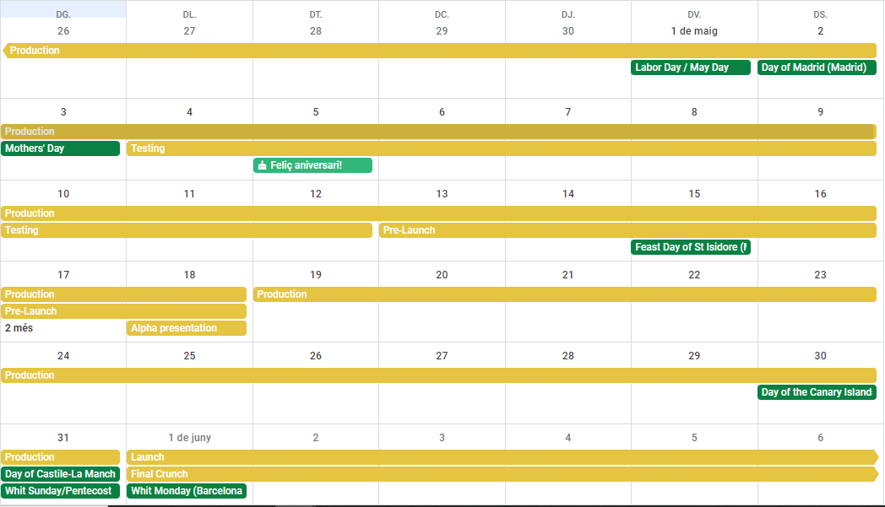

**June 2020**

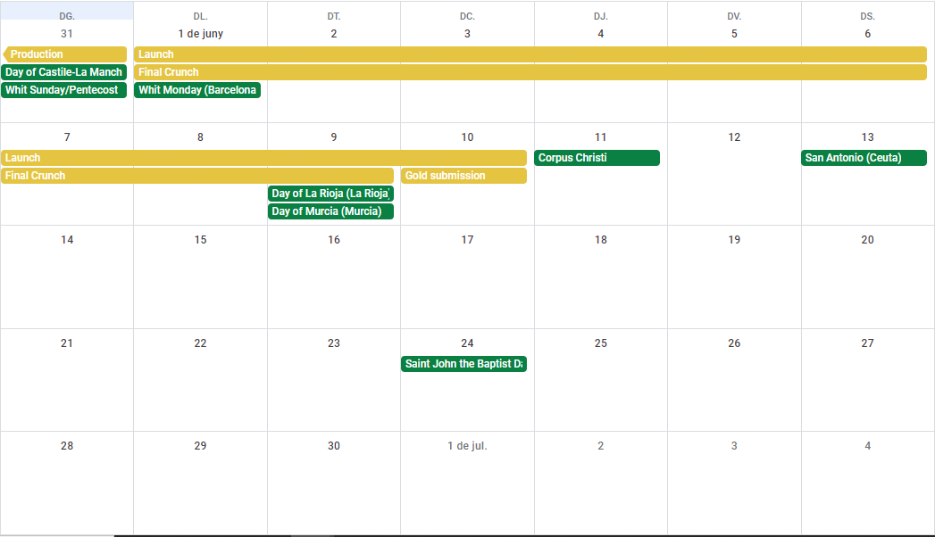

**Test Design:**

For the game developed by Misionero’s studios will use a mix of QA Department testing and UX testing in two differents stages of the Quality Testing process.

We will focus on automated tests like Stress tests and Unit tests for code and design tasks mostly. The following stages are some we will be testing:

* Economy of the game balance.
* Displacement of units in game.
* Performance of the game code.
* Memory leaks.
* Mechanics and dynamics errors or bugs.
* IA performance.

Then the manual tests will be focused for art, UI and user experience tasks, tests like Interface tests, Hurístic tests, Cognitive tour tests, Mechanical tests, Sound tests, Smoke tests, Stress tests and Smoke tests.The following stages are some we will be testing:

* The game art looks complete and non-bothering.
* Sounds are correctly delivered to the user and does not desconcentrate the user.
* The UI is understanding and it has the most possible accessibility for the users.
* The aesthetics of the assets in game correspond it use.
* The gameplay presents a learning curve, tutorial or difficulty progression process.

This are some of the tests we will be doing and some features we already know that will need testing, although there are a lot of mechanics, tasks and features that will require a testing in the future of the game and these will be added at these list while their development.

For these tests we are going to use heurístics reports, cognitive tours documents, bug reports, delivery methods files and some software like visual studio, github and tiled. We are using a proactive and based on risks mix, where we’re trying to prevent errors with the delivery protocol and the correction of these bugs with the bugs report file. We have in mind to the deficit of automated testing tools so we have designed this previous documents.

**Test Execution:**

Although we we’ll keep a constant process for testing the new features included during the development of the game with the Milestone Delivery Protocol we will have some time to implement the previous explained tests techniques. During this sections of time dedicated at testing the game will be the QA team who leads the process and will be divided in two specific plans of test: the Alpha and the Beta.

This will be the principals pillars of Alpha and Beta testing on Misionero’s Studios:

* Alpha testing will clear out most of the major bugs in the system while beta testing will try more like polishing the game.
* Alpha testing is won’t open to the public while beta testing could involve the public.

This to releases will be intended to test the game in differents ways before the gold submission, you can see the Alpha and the Beta processes explained more detailed in the following section: *Alpha and Beta testing*.

**Test/Bug report:**

We have created an specific document to report possible bugs that we find in game during the testing processes. This document contains the following features: reviewer information, bug information, bug description, administrative information and added notes.

The Bug Report will ensure all bugs are well descriptive and avoid chaos at the time to correct them, this way will know rapidly who found the bug, where is the bug, what's about the bug and which team will be the one who is in charge to correct it.

This bug report is explained in the following section: *Bug properties and workflow.*